CRIME WATCHERS’ APP
Group name: Neighborhood watch
Name | Surname | Student number | Phone number
Yonela | Didi | 222615753 | 0673889160
ASAVELA | KHUMALO | 222480963 | 222480963
LILONKE | BUSO | 221745467 | 0729409381
SINESIPHO | DYONASE | 221065989 | 0622504940
LUYOLO | DIKANA | 219225052 | 0727960256

TABLE OF CONTENT
App idea | Page 3
Use case diagram | Page 4
Prototype of our App | Page 5-8
The database | Page 8-

1.APP IDEA
The crime watcher’s application aims to provide a platform where individuals can report criminal activity in their local communities. Report individuals partaking in a criminal activity. Access a database of individuals that have partaken in criminal activity in the area. Allows community members to more easily police their own communities. At this stage the neighbourhood watch team has yet to come to a consensus on the design and the functions of the app, however the intended outcomes above are achievable within the scope of our abilities.
The main actors of this application are:
- Community members: can report crimes in detail and can upload images or videos as evidence.
- Community forum leaders: the user can discuss crime related topics or share information
- Station commander: assign crimes to officers for investigation, track investigation progress and status and monitor officer activity and performance.
- Police officers: access reported crimes in their jurisdiction, they also mark crimes as under investigation or resolved and update crime status and provide feedback to users.

The crime watcher application requirements and functionalities are:
-Dashboard: Station commander can overview the crime reports, investigations, and statistics for their station
- Crime Management: Station commander assign crimes to officers for investigation and track investigation progress and status
- Crime tracking: Community members track status of reported crimes.
-Communication tools: Officer can request additional information or evidence.
- Reporting tools:

2.USE CASE DIAGRAM

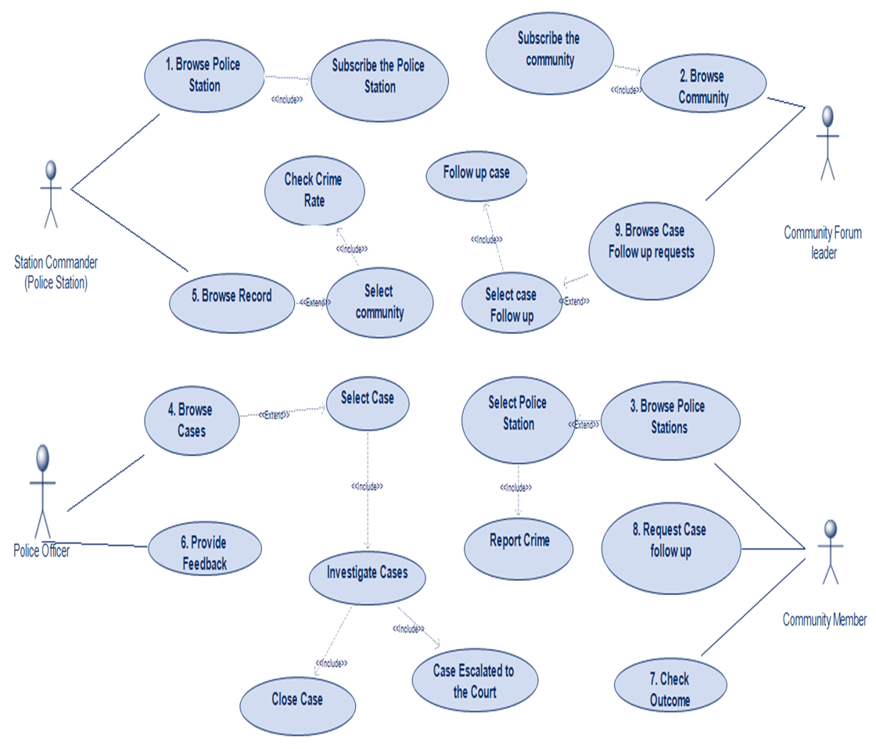

3.PROTOTYPE OF THIS APP

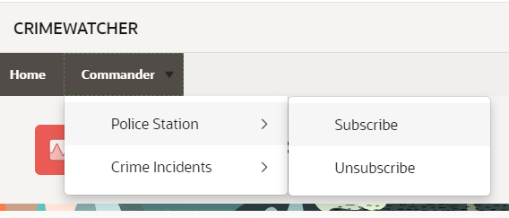

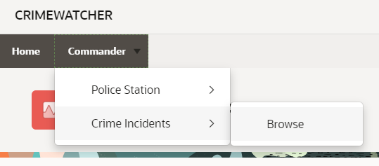

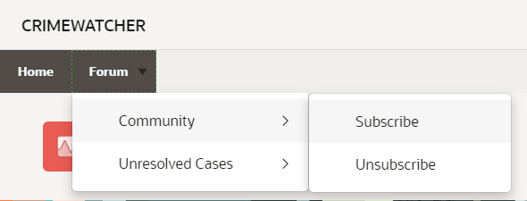

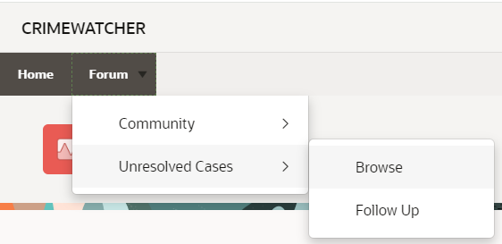

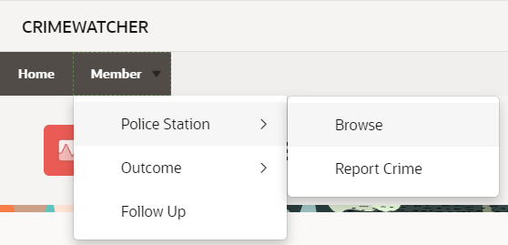

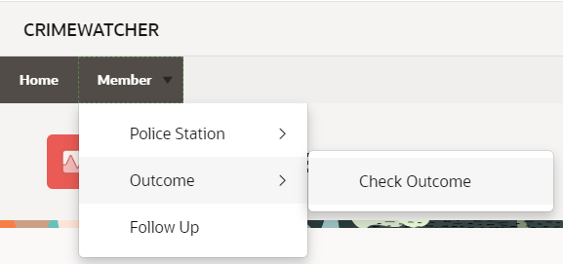
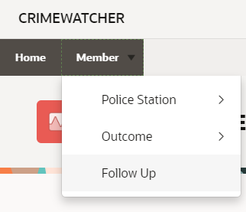

4.DATABASE
PERSONS (PID, FULLNAME, LASTNAME, PHONENUMBER, GENDER, ADDRESS, EMAIL, USERNAME)
AREA (AREAID, AREANAME)
AREASTATIONS (AREASTATIONID, AREAID, STATIONID)
CASES (CASEID, CASENUMBER, CASETYPE, DESCRIPTION, DATE_REPORTED, DATE_OCCURED, LOCATION)
COMMANDERS (COMMANDERID, COMMAND_AREANAME, AREAID)
COMMAND_AREA (COMMAND_IDAREA, COMMAND_AREANAME_AREAID)
FORUMLEADERS (FORUMLEADERID, PID, FORUMLEADER_STATIONID)
FORUMLEADER_STATIONS (FORUMLEADER_STATIONID, STATIONID)
MEMBERCASES (MEMBERCASEID, MEMBERID, CASEID)
MEMBERS (MEMBERID, PID, CASEID)
OFFICERS (OFFICERID, RANK, STATIONSTAFFID)
STAFF (STAFFID, PID, BADGENUMBER, LANDLINE)
STATIONMEMBERS (STATIONMEMBERSID, MEMBERID, STATIONID)
STATIONS (STATIONID, STATION_NAME)
STATIONSTAFFS (STATIONSTAFFID, STATIONID, STAFFID)
AREA
- This tables contains 2 columns.
- The AREAID column should contain the identification of area.
- The AREANAME column should contain the name of the area.

SCENARIO
The identification of the area’s ID is (AREAID) 25. The identification of the area name is Mdantsane.

AREASTATION
- This table contains 3 columns.
- The AREASTATIONID should contain the identification of the area station.
- The AREAID should contain the identification of the area.
- The STATIONID should contain the identification of the station.

SCENARIO
The identification of the area station’s ID is (AREASTATIONID) 7, the identification of the area’s ID is 7 and the station ID is 6.

CASES
- This table contains 7 columns.
- The CASEID should contain the identification of the case.
- The CASENUMBER should contain the number of the case.
- The CASETYPE should contain the type of the case.
- The DESCRIPTION should contain the brief description of the case.
- The DATE_REPORTED should contain the date the case was reported
- The DATE_OCCURED should contain the date the incident occured that is reported on the cases date
- The LOCATION should contain the location of where did the case occur
SCENARIO
The idenfication of the cases’ ID is (CASEID) 30 . The case number is 40 . The case type is Drug . The description is possession of drugs . The date the case was reported is 04-05-2024. The date the incident occurred is 03-05-2024. The location is Southernwood.

COMMANDERS
- This table contains 3 columns
- The COMMANDERID should contain the id of the commander
- The COMMAND_AREAID should contain the ID of the area the commander commands
- The Station_ID should contain the ID of the station Commander commands
SCENARIO
- The identification of the commanders ID is (COMMANDER_ID) 1. The COMMAND_AREAID is 1 . The station ID is 24.

COMMAND_AREA
- This table contains 3 columns
- COMMAND_AREA should contain the ID of the Command area
- The COMMAND_AREANAME should contain the name of the place the commander is commanding
- The STATIONID should contain the ID of the station

SCENARIO
The identification of the Command area is ( COMMAND_ARE) 2 . The command area name is Mdantsane. The area’s ID is 4.

FORUMLEADERS
- This table has 3 columns
- FORUMLEADERID should contain the ID of the forum leader
- PID should contain the persons ID
- FORUMLEADER_STATIONID should contain the the ID of the forum leader’s station
SCENARIO
The identitification of the forum leader's (FORUMLEADERID) 64. The person’s ID is 84 . Forum leader’s station is 24.

FORUMLEADER_STATIONS
- This table has 2 columns
- FORUMLEADER_STATIONID should contain the the ID of the forum leader’s station
- The STATIONID should contain the ID of the station
SCENARIO
- The identification of the forum leader’s station is (FORUMLEADER_STATIONID)24. The station ID is 4.
MEMBERS
- This table contains 3 columns
- MEMBERID should contain the members ID
- PID should contains the persons ID
- CASEID should contain the CASEID
SCENARIO
The identification of the members ID is (MEMBERID) 1 . The person ID is 16. The case ID IS 22
MEMBERCASES
- This table has three columns
- MEMBERCASESID should contain the Member case ID
- MEMBERID should contain the members ID
- CASEID should contain the case’s ID

SCENARIO
The identification of membercases is (MEMBERCASEID) 25 . The MEMBERID is 5 . The CASEID is 1.

OFFICERS
- This table contains 3 columns
- OFFICERID should contain the officer ID
- STATIONID should contain the Stations ID

